Course: Basics of Computer Science
Course Code: 26COA0101

Submitted By: Name: Kanwalpreet Singh
Roll no: 2610997039

Submitted To: Ms. Deepika Sharma
INDEX
Commands | Purpose
mkdir | Create a new directory
cd | Change the current directory
Cat > | Create/Write a text file
ls | List directory contents
sort | Sort lines for text
find | Search for a file
cp | Copy a file or directory
mv | Move or rename a file
rm | Remove a file

Directory structure used:
DIGITAL_Library
Books
Question_paper
Study_material
Backup

Note:
Text or press the ctrl+Z / F6 to finish the input and return to the shell.

Experiment: 1
1.Create the main Digital_Library directory
Input: mkdir DIGITAL_Library

Output:
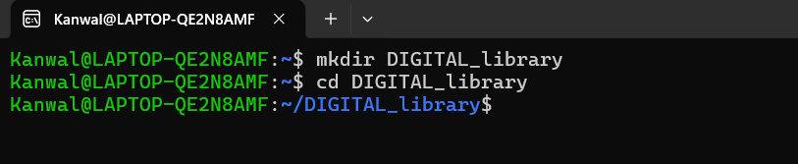

Experiment: 2
2.Change the DIGITAL_Library
Input: cd DIGITAL_Library

Output:

Experiment: 3
3.Create the books question_paper study_material backup directories
Input: mkdir books question_paper study_material backup

Output:
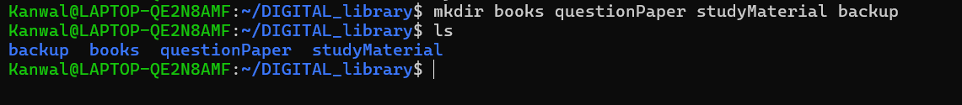
Experiment: 4
4.Enter the books directory
Input: cd books

Output:
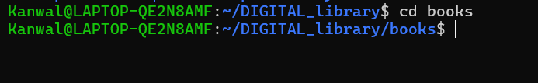

Experiment: 5
5.Create the write ( cat > ) file under books directory
Input: cat > DSA.txt
Hello world
File input shown above is completed with Ctrl+Z / F6.

Output:
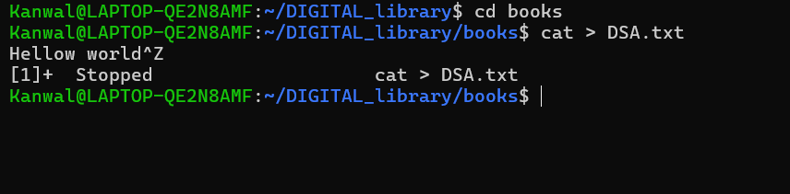

Experiment: 6
6.Return to the DIGITAL_Library
Input: cd ..

Output:
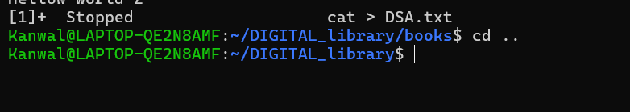

Experiment: 7
7.Enter the question_paper directory
Input: cd question_paper

Output:
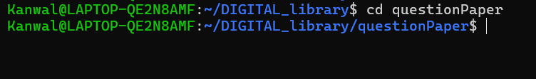

Experiment: 8
8. Create the write ( cat > ) file under question_paper
Input: cat > BCA_qp.txt
Japneet Kaur
File input shown above is completed with Ctrl+Z / F6.

Output:
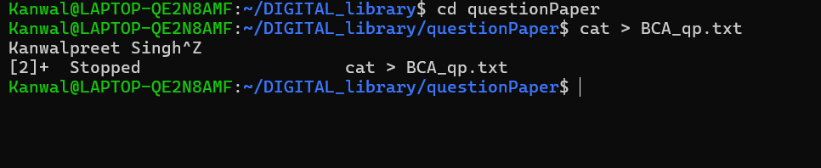

Experiment: 9
9. Return to the DIGITAL_Library
Input: cd ..

Output:
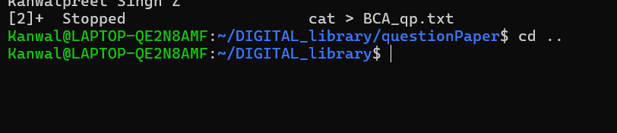

Experiment: 10
10. Enter the Study_material directory
Input: cd study_material

Output:
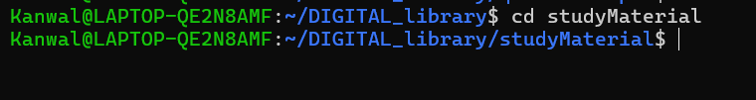

Experiment: 11
11. Create the write ( cat > ) file under study_material
Input: cat > python.txt
Punjab
File input shown above is completed with Ctrl+Z / F6.

Output:
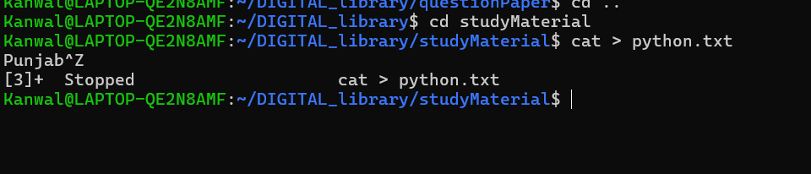

Experiment: 12
12. Return to the DIGITAL_Library
Input: cd ..

Output:
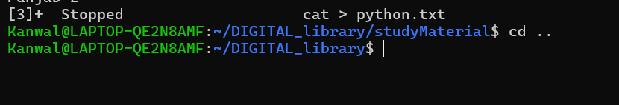

Experiment: 13
13. Enter the backup directory
Input: cd backup

Output:
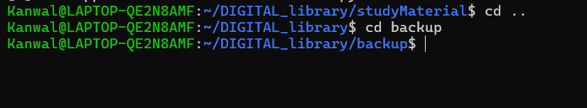

Experiment: 14
14. Create the write ( cat > ) file under backup
Input: cat > math_notes.txt
Good morning
File input shown above is completed with Ctrl+Z / F6.

Output:
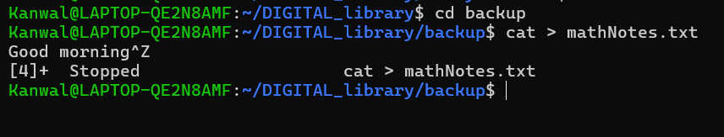

Experiment: 15
15. Return to the DIGITAL_Library
Input: cd ..

Output:
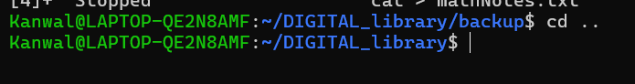

Experiment: 16
16.List the directory contents – ls
Input: ls

Output:
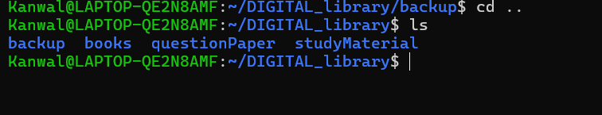

Experiment: 17
17.Sort the files
Input: ls | sort

Output:
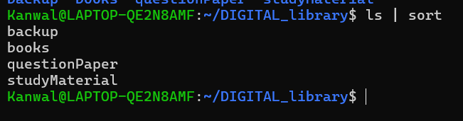

Experiment: 18
18.Searching a file – find
Input: find . -name ”python.txt”

Output:
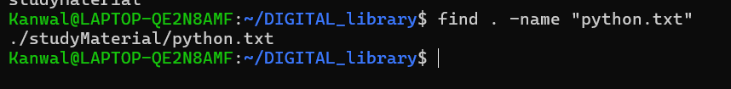

Experiment: 19
19.Copy the files
Input: cp DSA.txt../backup/

Output:
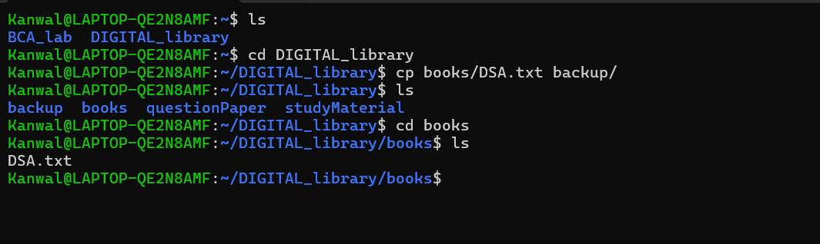

Experiment: 20
20.Move the file
Input: mv question_paper/BCA_qp.txt books/

Output:

Experiment: 20
21.Remove the backup file – math_notes.txt
Input: rm backup/math_notes.txt

Output:



